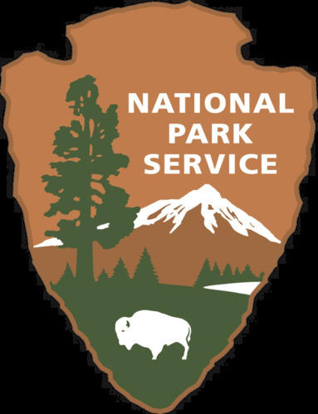
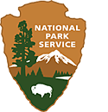
Mount Rushmore National Memorial
National Park Service
U.S. Department of the Interior

The Arrowhead
How we give meaning to symbols

Table of Contents

Introduction pg. 3

Activity worksheets pg. 5

References and Resources pg. 7

Introduction

Theme
The National Park Service (NPS) Logo is a well known symbol. We can derive meaning from symbols and learn how to apply our own values to symbols.

Education Standards

SD 2nd Grade
2.RL.7 Use illustrations and words in a print or digital text to demonstrate understanding of its characters, setting, or plot.
2.RI.7 Explain how specific images (e.g., photographs, charts, diagrams contribute to and clarify a text.
2.RI.1 Ask and answer such questions as who, what, where, when, why, and how to demonstrate understanding of key details in a text.
2.SL.5 Create audio recordings, visual displays, performances, or media presentations of stories or poems to express ideas, thoughts, and feelings

Activity
You as a Symbol: Students will draw their own logo on the arrowhead, creating symbols that covey meaning about their own lives.

Key Vocabulary
Symbol, Arrowhead, Organic Act, protect, preserve, archaeological, vegetation.

Objectives
Students will be able to define what a symbol is, and be able to identify aspects that the National Park Service protects.

Background
History of the Arrowhead:
The NPS Arrowhead is a logo known far and wide. It’s in Visitor Centers, on park signs, and has become a popular symbol.
The NPS has been around since 1916, when Congress passed the Organic Act. This act was signed by President Woodrow Wilson to establish the NPS for regulating use of Federal land.
During that time, there were few attempts to create a logo or symbol to represent the Park Service. For the first few years an informal logo was used that featured a sequoia pinecone with branches, but it didn’t catch on and was quickly discarded.
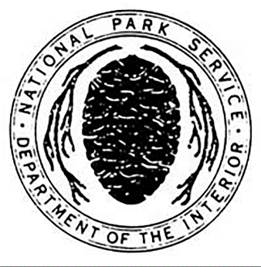
Years pass until 1951 when a team of NPS employees crafted the Arrowhead logo used today, with the Secretary of the Interior authorizing its widespread use.
One year later, Oregon Caves National Monument became the first park to use the Arrowhead in park brochures. Finally, in 1955 we see the Arrowhead make its way onto the official NPS uniform.
The NPS is tasked with protecting many areas of interest, and those are represented by the symbols on the Arrowhead.
The Arrowhead itself represents historical and archaeological values. The tree and bison represent the wildlife and vegetation protected. The mountain and water stand for all recreation opportunities and scenery preserved.

Background continued
But before we let the class know what the symbols on the Arrowhead represent, let’s get their input.
Project or display the NPS Arrowhead for the class to see and have students pick out things they notice. What do they think these things represent? Why are those things important? Is there anything they think is missing from the Arrowhead?
The NPS mission is to protect and preserve places for the enjoyment of future generations. Can the students define protect and preserve? Protect is to keep safe from harm. Preserve means to maintain something in its original state.
So, these symbols on the Arrowhead—how do they symbolize protection and preservation? The bison could show that we protect animals, the tree that we want to preserve nature. Get input from students before moving on to the activity.
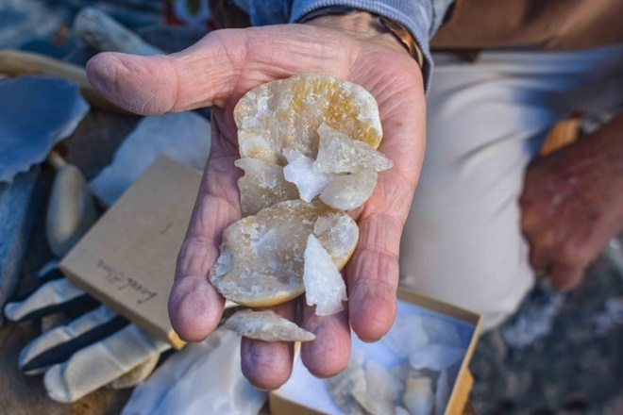
Arrowheads were common tools of Native Americans. NPS Image.

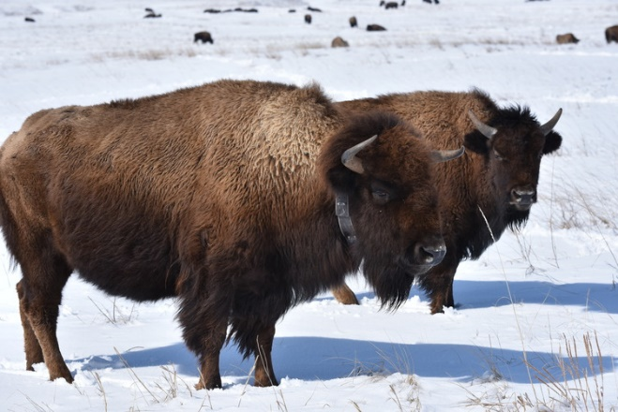
A bison is on the NPS Arrowhead to show that a major aspect of the NPS is to protect wildlife. NPS/Abby Jo Rimstidt

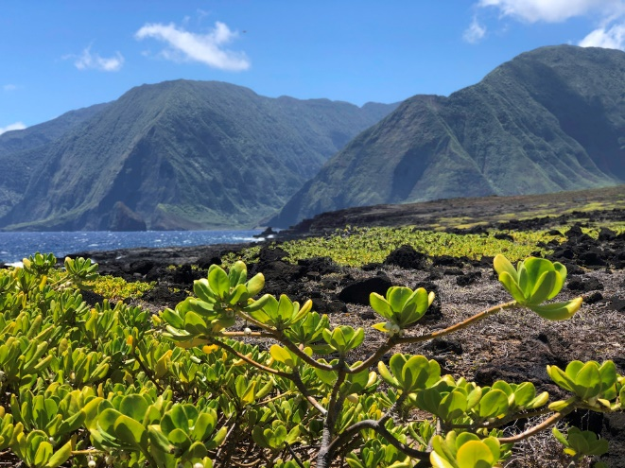
This Hawaii habitat protects several federally endangered plant species, Like the Haha and Alani. NPS/Hailey Shchpanik.

You As a Symbol

Duration
~20 Minutes

Location
Indoors

Objectives
Students will identify important aspects about their own selves and interests and be able to symbolize those on a drawing.

Materials
Enlarged version of arrowhead, pen or pencil, markers, crayons, colored pencils, optional for other craft supplies.

Suggested Procedure
- After students have finished their individual projects, we will create a class symbol
- Invite students up to the class arrowhead and have them draw ONE thing from their personal drawing on the class version.
- Once everyone has contributed to the class symbol, debrief how all individual parts and students can come together to create new meaning as part of the bigger picture/whole class.

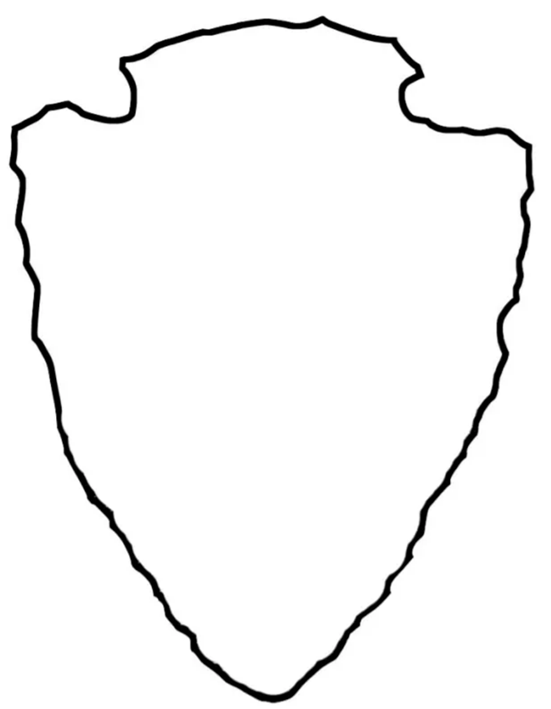
NPS Image

You As a Symbol

Duration
~20 Minutes

Location
Indoors

Objectives
Students will learn to blend ideas and infer greater meaning from symbols.

Materials
Enlarged version of arrowhead, pen or pencil, markers, crayons, colored pencils, optional for other craft supplies.

Suggested Procedure
- After students have finished their individual projects, we will create a class symbol
- Invite students up to the class arrowhead and have them draw ONE thing from their personal drawing on the class version.
- Once everyone has contributed to the class symbol, debrief how all individual parts and students can come together to create new meaning as part of the bigger picture/whole class.

NPS Image

Resources
NPS Organic Act of 1916. NPS.gov. (2019). Retrieved January 30, 2023 from https://www.nps.gov/pipe/learn/management/nps-organic-act-of-1916.htm.

History of the NPS Arrowhead. NPS.gov. (2022). Retrieved January 30, 2023 from https://www.nps.gov/wrst/learn/historyculture/history-of-the-nps-arrowhead.htm.

